ICAAM2023 Title Style sample
First Authora, Second Authorb,∗, Third Authora
aAuthor(s) affiliation, department, Street, City, 12345-6, State, Country
bAuthor(s) affiliation, department, Street, City, 12345-6, State, Country
ABSTRACT. These instructions give you guidelines for preparing the paper for the 9th Int. Conf. on Advances and Applied Mathematics, December 19-23, 2022, Djerba island, Tunisia. Please present the motivations of the contribution, the method- ology used. Acknowledgements and selected references have to be placed at the end. Please contain all the text in maximum six pages. These instructions should be read carefully. The conference benefits from a detect plagiarism procedure. The result couldn’t exceed 40 % in reproduction quality.
Keywords: first keyword, second keyword, third keyword

Submission
Authors are invited to submit 1-page digest, in line with the themes of the conference, in the format available on the conference web site. All digest must be submitted in PDF format directly on the conference website via the online submission system. Digests sent via email or regular mail will not be processed or acknowledged. After a peer-review process, the authors of the accepted short papers will be invited to present their research work at SMM25, by oral or poster presentations, and to submit 4-page full papers for possible publication in a special issue of a Journal (envisaged in the Journal of Magnetism and Magnetic Materials). More details about the format are posted on the conference web site. Authors will be informed of the status of their submission via e-mail on 15th December 2021. For any further information, please contact the workshop organizers at smm25@sciencesconf.org.

Styles
All text throughout the paper should be written in Times New Roman single-spaced, and respect the following font sizes: 24pt should be used for title, 11pt for author’s name, 11pt for author’s affiliations, 10pt for keywords, 11pt for main text, 9pt for figure and table captions, 10pt for references. If you use nonstandard fonts for special symbols, please embed them in the PDF (export option).

Citations
Number citations consecutively in square brackets [1]. The sentence punctuation follows the brackets [2]. Multiple references [2], [3] are each numbered with separate brackets [2]-[3]. When citing a section in a book, please give the relevant page numbers [2]. In sentences, refer simply to the reference number, as in [3]. Do not use “Ref. [3]” or “reference [3]” except at the beginning of a sentence. Papers that have not been published should be cited as “unpublished”. Papers that have been submitted for publication should be cited as “submitted for publication”. Papers that have been accepted for publication but not yet specified for an issue should be cited as “to be published”.
u(x, y, z) = v(x, y, z) + w(x, y, z) | (1)
Place figures and tables in the middle of column. Figure captions should be left justified below the figures.
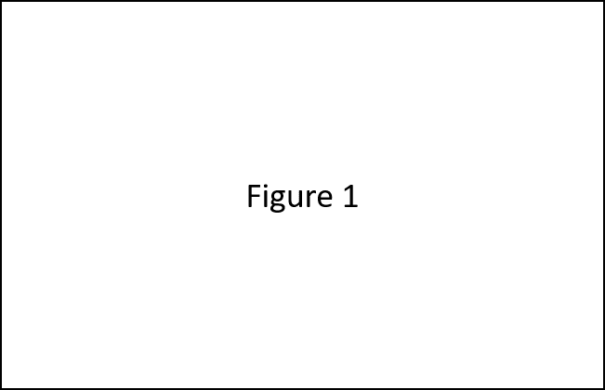
Figure 1 : Figure caption
Table captions should be centred above the tables. Please use words rather than symbols to label the axes.
Table 1 : Table caption
Column A | Column B
1.0 | 2.0
2.0 | 2.1
3.0 | 2.2

References
[1] Hubert, A., Schäfer, R., "Magnetic Domains", ed Springer, Berlin (1998), 38.
[2] Sievert, J., ``Recent advances in the one- and two-dimensional magnetic measurement technique for electrical sheet steel'', IEEE Trans. Magn., 26 (1990), 2553-2558.
[3] Gilbert, T. L., "Formulation, Foundations and Applications of the Phenomenological Theory of Ferromagnetism", Ph.D. dissertation, Illinois Inst. Tech., Chicago, IL, (1956), unpublished

